Spatial Filtering Techniques for Image Enhancement

1. Introduction
Image enhancement is a fundamental task in computer vision and digital image processing. Real-world images often contain noise, low contrast, or blurred regions that make it difficult to extract useful information. Spatial filtering, which directly operates on pixels and their neighborhoods, is an essential technique for enhancing visual quality, suppressing noise, and improving feature visibility.
This report investigates the application of various spatial filtering techniques—including mean, median, mode, Sobel, Laplacian, sharpening, smoothing, thresholding, negative transformation, gamma correction, and contrast adjustments—to images with distinct challenges: a medical X-ray image with a small embedded object (bullet) and a noisy colored anime image captured at night. The study emphasizes how different filters behave on different image types and identifies the most effective combinations.

2. Dataset Description
Two images were selected for experimentation:
- Medical X-ray Image (Grayscale): A chest X-ray with a small embedded bullet fragment. The task is to enhance contrast and clarity to make the foreign object more visible. This represents real-world diagnostic imaging where spatial filtering can improve radiological interpretation.
- Anime Image (Colored): A low-light scene with noise. The objective is to enhance details and reduce noise while preserving color fidelity. This type of image is common in multimedia applications where perceptual quality is important.
The dataset was intentionally chosen to cover both grayscale diagnostic imaging and colored noisy natural images, allowing evaluation of filters across different domains.

3. Methodology & Justification

3.1 Mean (Averaging Filter)
- Implementation: Using a 5×5 kernel in OpenCV (cv2.blur).
- Justification: Smooths noise by averaging pixel neighborhoods. Useful for reducing random noise but at the cost of blurring edges.

3.2 Median Filter
- Implementation: OpenCV’s cv2.medianBlur.
- Justification: Non-linear filter replacing each pixel with the median of its neighborhood. Particularly effective for salt-and-pepper noise in medical and natural images.

3.3 Mode Filter
- Implementation: Custom NumPy-based code calculating the most frequent pixel intensity in a neighborhood.
- Justification: Preserves dominant intensity values while removing outliers. Effective when noise is repetitive and structured.

3.4 Sobel Operator
- Implementation: OpenCV’s cv2.Sobel.
- Kernel:
  - Horizontal: [−1,0,1;−2,0,2;−1,0,1][-1, 0, 1; -2, 0, 2; -1, 0, 1][−1,0,1;−2,0,2;−1,0,1]
  - Vertical: [−1,−2,−1;0,0,0;1,2,1][-1, -2, -1; 0, 0, 0; 1, 2, 1][−1,−2,−1;0,0,0;1,2,1]
- Justification: First-derivative operator highlighting edges in x and y directions. Useful for detecting the outline of objects such as the bullet in the X-ray.

3.5 Laplacian Operator
- Implementation: OpenCV’s cv2.Laplacian.
- Kernel: [0,−1,0;−1,4,−1;0,−1,0][0, -1, 0; -1, 4, -1; 0, -1, 0][0,−1,0;−1,4,−1;0,−1,0]
- Justification: Second-derivative operator that enhances fine details and edge structures. Effective for high-frequency content such as bone outlines and metallic objects.

3.6 Filter Combinations (Sharpen + Smooth)
- Implementation: Sequential application of sharpening followed by smoothing.
- Justification: Sharpening enhances details, while smoothing reduces noise introduced during sharpening. This balance often yields the most visually pleasing results.
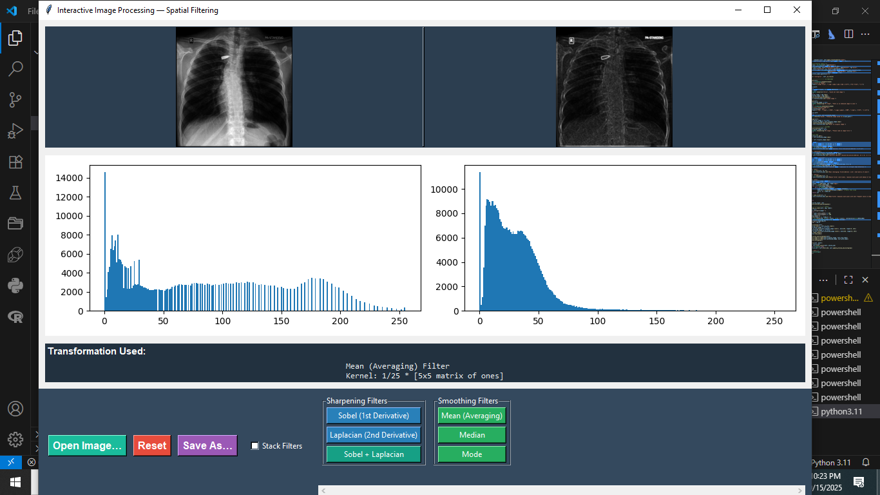

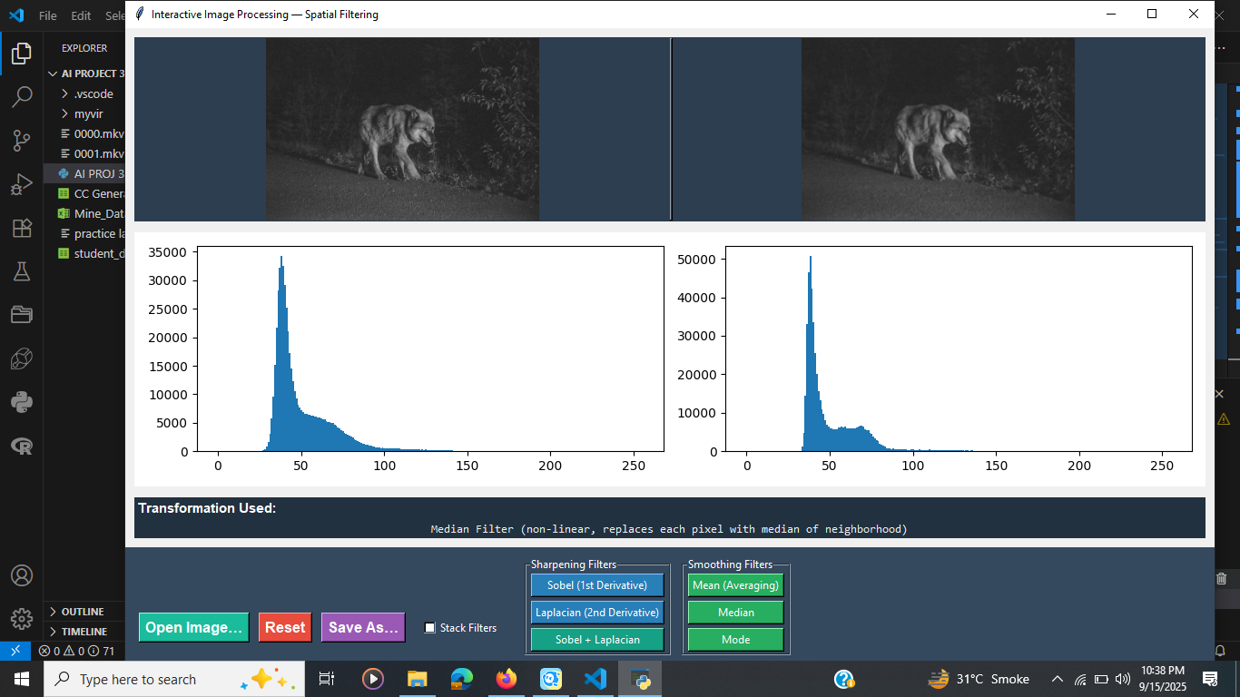
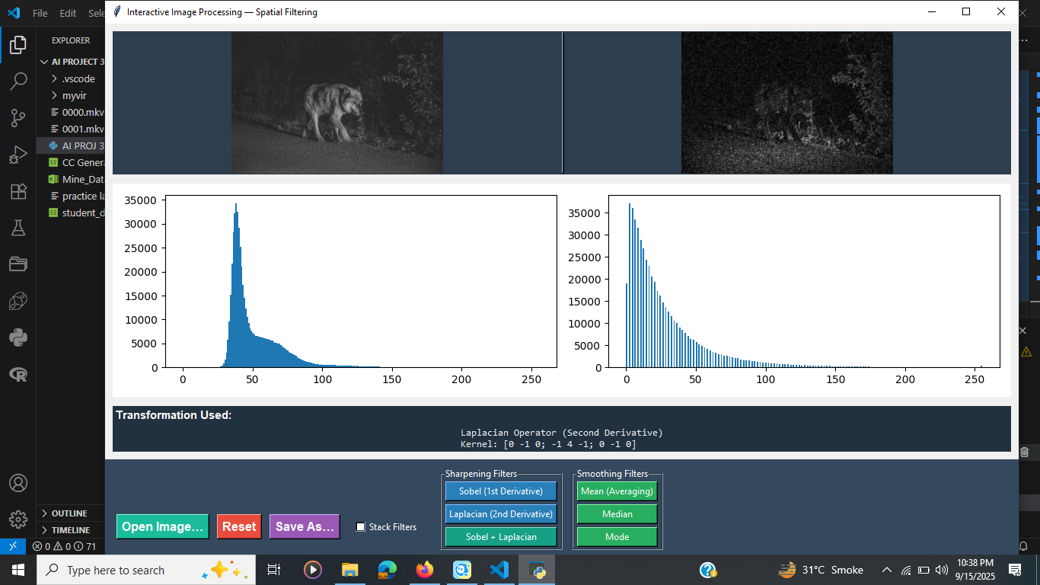
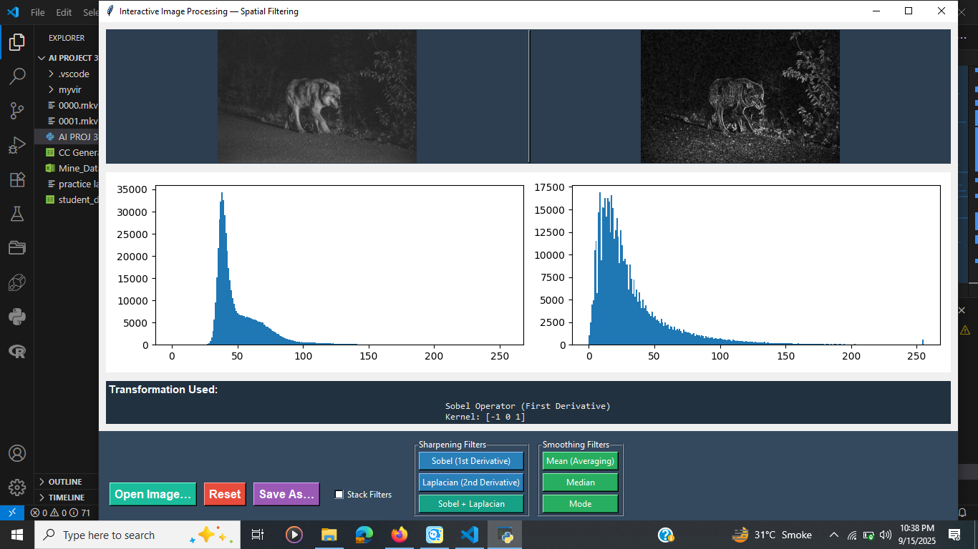
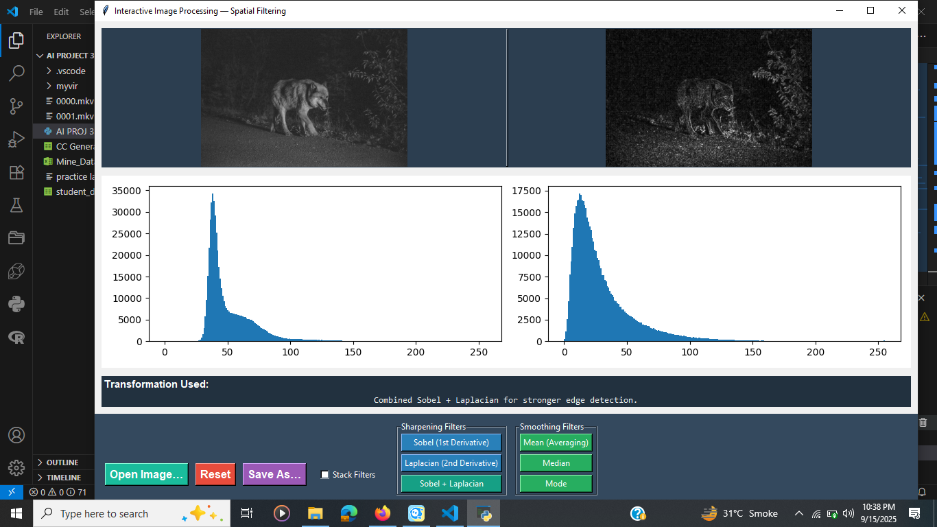

4. Results & Analysis
- X-ray Image:
  - The Negative transformation provided the clearest bullet visibility by enhancing the low-intensity region.
  - The Laplacian operator highlighted fine edges of the bone structure and bullet fragment.
  - Thresholding failed to capture the bullet due to its small size.
  - Sharpen + Smooth combination offered enhanced clarity while reducing artifacts.
- Anime Image:
  - Median and Mode filters reduced noise effectively while preserving edges.
  - Gamma correction improved dark region visibility.
  - Contrast stretching further enhanced overall brightness and contrast.
  - The Sharpen + Smooth combination improved both detail and perceptual quality.
Comparative analysis shows that no single filter is universally optimal. Instead, combinations tailored to image type yield the best performance.

5. Conclusion
This study demonstrated the importance of spatial filtering in image enhancement for both grayscale medical and colored noisy images. The results indicate:
- Negative transformation is highly effective in medical imaging when detecting small foreign objects.
- Laplacian and Sobel filters are suitable for highlighting edges and fine details.
- Median and Mode filters are well-suited for noisy natural images.
- Sharpen + Smooth combination provides a balanced improvement across both domains, reducing noise while preserving important details.
Thus, spatial filtering remains an indispensable tool in computer vision, with filter choice highly dependent on image characteristics and task requirements.

6. Appendix: Code Implementation
The following code was developed in Python (OpenCV + Tkinter) to implement the described filtering methods. It includes options for:
- Loading images from any directory
- Applying filters individually or in combination
- Visualizing results
- Saving enhanced images

import tkinter as tk
from tkinter import filedialog, messagebox
from tkinter import ttk
from PIL import Image, ImageTk
import cv2
import numpy as np
from matplotlib.backends.backend_tkagg import FigureCanvasTkAgg
from matplotlib.figure import Figure

class ImageProcessorApp(tk.Tk):

def __init__(self):
super().__init__()
self.title("Interactive Image Processing — Spatial Filtering")
self.geometry("1200x820")
self.minsize(900, 600)

self.original_image = None
self.processed_image = None
self.last_transform_text = tk.StringVar(value="Load an image to begin…")
self._resize_job = None
self.stack_var = tk.BooleanVar(value=False) # NEW: stacking option

self.setup_ui()

# ----------------------------- UI LAYOUT
def setup_ui(self):
# === IMAGE PANES ===
top = tk.Frame(self, bg="#2c3e50")
top.pack(side="top", padx=10, pady=(10, 6), fill="both", expand=True)

pane = tk.PanedWindow(top, orient=tk.HORIZONTAL, sashrelief='raised', bg="#2c3e50")
pane.pack(fill="both", expand=True)

left_panel = tk.Frame(pane, bg="#2c3e50", width=600, height=360)
right_panel = tk.Frame(pane, bg="#2c3e50", width=600, height=360)
pane.add(left_panel)
pane.add(right_panel)

self.orig_label = tk.Label(left_panel, bg="#2c3e50")
self.orig_label.pack(fill="both", expand=True)
self.proc_label = tk.Label(right_panel, bg="#2c3e50")
self.proc_label.pack(fill="both", expand=True)

# === HISTOGRAMS ===
mid = tk.Frame(self, bg="#243447")
mid.pack(side="top", padx=10, pady=(6, 6), fill="x")

self.fig = Figure(figsize=(10, 2.8), dpi=100)
self.ax_orig = self.fig.add_subplot(1, 2, 1)
self.ax_proc = self.fig.add_subplot(1, 2, 2)
self.ax_orig.set_title("Original Histogram")
self.ax_proc.set_title("Enhanced Histogram")

self.canvas = FigureCanvasTkAgg(self.fig, master=mid)
self.canvas.get_tk_widget().pack(fill="x", expand=False)

# === BOTTOM CONTROLS ===
bottom = tk.Frame(self, bg="#34495e", padx=10, pady=10)
bottom.pack(side="bottom", fill="x")

file_frame = tk.Frame(bottom, bg="#34495e")
file_frame.grid(row=0, column=0, sticky="w", padx=(0, 10))

tk.Button(file_frame, text="Open Image…", command=self.open_image,
bg="#1abc9c", fg="white", font=("Helvetica", 12, "bold")).pack(side="left", padx=5)
tk.Button(file_frame, text="Reset", command=self.reset_image,
bg="#e74c3c", fg="white", font=("Helvetica", 12, "bold")).pack(side="left", padx=5)
tk.Button(file_frame, text="Save As…", command=self.save_image,
bg="#9b59b6", fg="white", font=("Helvetica", 12, "bold")).pack(side="left", padx=5)

# NEW: Checkbox for stacking
tk.Checkbutton(file_frame, text="Stack Filters", variable=self.stack_var,
bg="#34495e", fg="white").pack(side="left", padx=10)

# === TRANSFORMATIONS ===
trans_container = tk.Frame(bottom, bg="#34495e")
trans_container.grid(row=0, column=1, sticky="ew")
bottom.grid_columnconfigure(1, weight=1)

trans_canvas = tk.Canvas(trans_container, bg="#34495e", highlightthickness=0, height=140)
trans_scroll = ttk.Scrollbar(trans_container, orient="horizontal", command=trans_canvas.xview)
self.trans_inner = tk.Frame(trans_canvas, bg="#34495e")
self.trans_inner.bind(
"<Configure>", lambda e: trans_canvas.configure(scrollregion=trans_canvas.bbox("all"))
)
trans_canvas.create_window((0, 0), window=self.trans_inner, anchor="nw")
trans_canvas.configure(xscrollcommand=trans_scroll.set)
trans_canvas.pack(fill="x", expand=True)
trans_scroll.pack(fill="x", expand=False)

# === Sharpening Filters ===
sharp_frame = tk.LabelFrame(self.trans_inner, text="Sharpening Filters", bg="#34495e", fg="white")
sharp_frame.pack(side="left", padx=6)

tk.Button(sharp_frame, text="Sobel (1st Derivative)",
command=lambda: self.apply_transformation("sobel"),
bg="#2980b9", fg="white").pack(pady=2, padx=5, fill="x")

tk.Button(sharp_frame, text="Laplacian (2nd Derivative)",
command=lambda: self.apply_transformation("laplacian"),
bg="#2980b9", fg="white").pack(pady=2, padx=5, fill="x")

tk.Button(sharp_frame, text="Sobel + Laplacian",
command=lambda: self.apply_transformation("sobel_laplacian"),
bg="#16a085", fg="white").pack(pady=2, padx=5, fill="x")

# === Smoothing Filters ===
smooth_frame = tk.LabelFrame(self.trans_inner, text="Smoothing Filters", bg="#34495e", fg="white")
smooth_frame.pack(side="left", padx=6)

tk.Button(smooth_frame, text="Mean (Averaging)",
command=lambda: self.apply_transformation("mean"),
bg="#27ae60", fg="white").pack(pady=2, padx=5, fill="x")

tk.Button(smooth_frame, text="Median",
command=lambda: self.apply_transformation("median"),
bg="#27ae60", fg="white").pack(pady=2, padx=5, fill="x")

tk.Button(smooth_frame, text="Mode",
command=lambda: self.apply_transformation("mode"),
bg="#27ae60", fg="white").pack(pady=2, padx=5, fill="x")

# === Transformation report ===
report_frame = tk.Frame(self, bg="#22313f")
report_frame.pack(fill="x", padx=10, pady=(6, 10))
tk.Label(report_frame, text="Transformation Used:", bg="#22313f", fg="white",
font=("Helvetica", 11, "bold")).pack(anchor="w")
self.transform_label = tk.Label(report_frame, textvariable=self.last_transform_text,
bg="#22313f", fg="#ecf0f1", justify="left",
font=("Consolas", 10))
self.transform_label.pack(fill="x")

self.bind('<Configure>', self._on_resize)

# ----------------------------- IO FUNCTIONS
def open_image(self):
filepath = filedialog.askopenfilename(
title="Select an Image",
filetypes=(("Image files", "*.jpg *.jpeg *.png *.bmp *.tiff"), ("All files", "*.*"))
)
if not filepath:
return
img = cv2.imread(filepath, cv2.IMREAD_GRAYSCALE)
if img is None:
messagebox.showerror("Error", "Could not load image.")
return
self.original_image = img.copy()
self.processed_image = img.copy()
self.update_preview_and_histograms()
self.last_transform_text.set("Loaded image.")

def save_image(self):
if self.processed_image is None:
messagebox.showwarning("No Image", "There is no enhanced image to save.")
return
save_path = filedialog.asksaveasfilename(
title="Save Enhanced Image As",
defaultextension=".png",
filetypes=(("PNG", "*.png"), ("JPEG", "*.jpg;*.jpeg"), ("BMP", "*.bmp"), ("TIFF", "*.tiff"))
)
if not save_path:
return
cv2.imwrite(save_path, self.processed_image)
messagebox.showinfo("Saved", f"Enhanced image saved to:\n{save_path}")

def reset_image(self):
if self.original_image is not None:
self.processed_image = self.original_image.copy()
self.update_preview_and_histograms()
self.last_transform_text.set("Reset to original image.")

# ----------------------------- FILTERS
def apply_transformation(self, t):
if self.original_image is None:
messagebox.showwarning("No Image", "Please load an image first.")
return

# NEW: stack mode
if self.stack_var.get():
src = self.processed_image.copy()
else:
src = self.original_image.copy()

if t == "sobel":
sobelx = cv2.Sobel(src, cv2.CV_64F, 1, 0, ksize=3)
sobely = cv2.Sobel(src, cv2.CV_64F, 0, 1, ksize=3)
dst = cv2.magnitude(sobelx, sobely)
dst = np.uint8(np.clip(dst, 0, 255))
self.last_transform_text.set("Sobel Operator (First Derivative)\nKernel: [-1 0 1]")

elif t == "laplacian":
dst = cv2.Laplacian(src, cv2.CV_64F, ksize=3)
dst = np.uint8(np.clip(np.absolute(dst), 0, 255))
self.last_transform_text.set("Laplacian Operator (Second Derivative)\nKernel: [0 -1 0; -1 4 -1; 0 -1 0]")

elif t == "sobel_laplacian":
sobelx = cv2.Sobel(src, cv2.CV_64F, 1, 0, ksize=3)
sobely = cv2.Sobel(src, cv2.CV_64F, 0, 1, ksize=3)
sobel = cv2.magnitude(sobelx, sobely)
lap = cv2.Laplacian(src, cv2.CV_64F, ksize=3)
combined = cv2.addWeighted(sobel, 0.5, np.absolute(lap), 0.5, 0)
dst = np.uint8(np.clip(combined, 0, 255))
self.last_transform_text.set("Combined Sobel + Laplacian for stronger edge detection.")

elif t == "mean":
dst = cv2.blur(src, (5, 5))
self.last_transform_text.set("Mean (Averaging) Filter\nKernel: 1/25 * [5x5 matrix of ones]")

elif t == "median":
dst = cv2.medianBlur(src, 5)
self.last_transform_text.set("Median Filter (non-linear, replaces each pixel with median of neighborhood)")

elif t == "mode":
def mode_filter(image, ksize=3):
pad = ksize // 2
padded = np.pad(image, pad, mode='edge')
out = np.zeros_like(image)
for i in range(image.shape[0]):
for j in range(image.shape[1]):
window = padded[i:i+ksize, j:j+ksize].flatten()
mode_val = np.bincount(window).argmax() # faster than scipy
out[i, j] = mode_val
return out

dst = mode_filter(src, 3)
self.last_transform_text.set("Mode Filter (replaces each pixel with most frequent value in neighborhood)")

else:
return

self.processed_image = dst
self.update_preview_and_histograms()

# ----------------------------- UTILS
def _show_image_in_label(self, img, label):
if img is None:
label.configure(image='')
return
frame_w = label.winfo_width() or 400
frame_h = label.winfo_height() or 300
h, w = img.shape[:2]
scale = min(frame_w / w, frame_h / h)
resized = cv2.resize(img, (int(w * scale), int(h * scale)), interpolation=cv2.INTER_AREA)
img_tk = ImageTk.PhotoImage(image=Image.fromarray(resized))
label.configure(image=img_tk)
label.image = img_tk

def update_histograms(self):
self.ax_orig.clear(); self.ax_proc.clear()
if self.original_image is not None:
self.ax_orig.hist(self.original_image.ravel(), bins=256, range=(0, 255))
if self.processed_image is not None:
self.ax_proc.hist(self.processed_image.ravel(), bins=256, range=(0, 255))
self.fig.tight_layout()
self.canvas.draw_idle()

def update_preview_and_histograms(self):
self._show_image_in_label(self.original_image, self.orig_label)
self._show_image_in_label(self.processed_image, self.proc_label)
self.update_histograms()

def _on_resize(self, event):
if self._resize_job:
try: self.after_cancel(self._resize_job)
except Exception: pass
self._resize_job = self.after(180, self.update_preview_and_histograms)

if __name__ == "__main__":
app = ImageProcessorApp()
app.mainloop()

